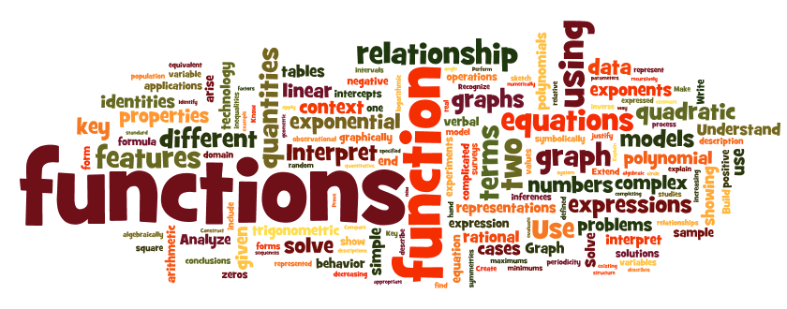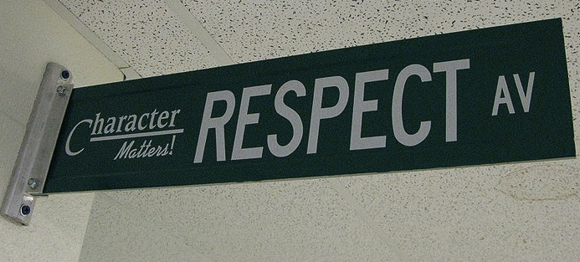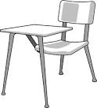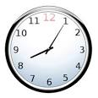

Homework is not busywork. It is necessary for you to complete in order to participate in class the next day or to develop important skills. My website contains a calendar of homework assignments to help you keep track of your assignments. If you choose not to complete the assigned work, you are missing out on the opportunity to learn and grow. In the past, students who didn’t complete homework struggled to complete Algebra 2, while students who regularly completed homework succeeded.

You will be given homework daily, however, you will usually have time in class to work on the assignment. The next day, we will go over any questions on the homework. The day of the quiz, you will be given an Assignment Accuracy Check (AAC) and this will count towards your homework grade. It will consist of 5 questions from your homework set and they are graded on accuracy.

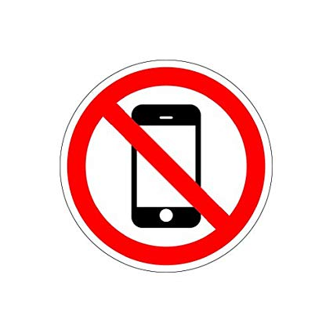

Welcome to Algebra 2. In this class the fundamental skills of mathematics will be applied to such topics as functions, equations and inequalities, probability and statistics, logarithmic and exponential relationships, quadratic and polynomial equations, and matrices. Technology will be used to introduce and expand upon the areas of study listed above. Use of computers and graphing calculators will be incorporated into each unit.

## Homework

# Course Description

#### Be kind & be respectful.

### Class Expectations

#### Absolutely no cell phones!!!

#### Raise your hand and wait to be called on before speaking.

All school rules also apply.

#### Complete all activities and assignments

#### Be on time & be prepared.

Algebra 2

**Email**: [khop@fhps.net](mailto:khop@fhps.net)

**Website**: hopmathematics.weebly.com

**Online Book**: pearsonsuccessnet.com

Username: FHEHawks1819

Password: algebra1

**Online Resources**: phschool.com

## Important Information:

**YOU WILL NEED:**

* Folder/binder
* Pencils only!!
* Graphing Calculator
* Completed homework assignments
* A positive attitude, a sense of humor, & an open mind

**Entering Class:** Gather any necessary materials, turn in any assignments, and quickly find your seat.

**Food & Drink:** Food and drink are permitted, however, please clean up after yourself.

**Phones**: **should not** be seen or heard in the classroom. They should be kept in your locker at all times.

**Absences:** If you are absent, it is your responsibility to make up missed assignments. See the “Absent” folder for handouts.

**Test Retakes:** If you did not pass a test, you do have the opportunity to retake the test. You will need to complete a review packet before retaking the test. After the packet is complete and corrected, you may retake the test before or after school.

**Missing Assignments:** You may not make up any missing questions on the AAC

## Classroom Policies, Procedures, & Grading