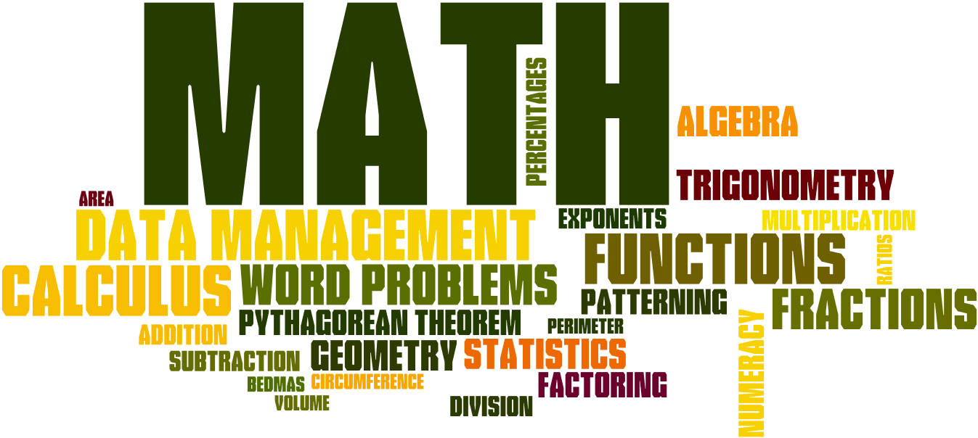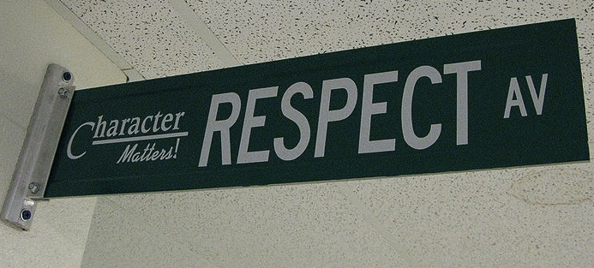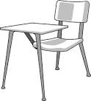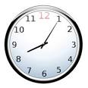

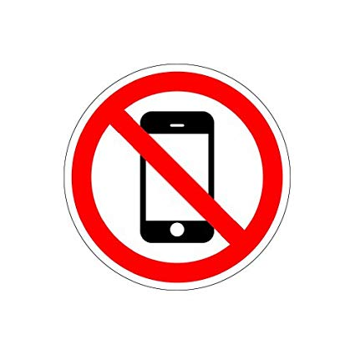

Welcome to Alg/Geo 1. This is the first of a two-year course that will cover the essential concepts in Algebra and Geometry. Our goal for the year is to build confidence in math and to build on our Algebraic knowledge. We will be learning about algebraic expressions, how to solve equations and inequalities, systems of equations, exponents, and an introduction into Geometry.

Homework is not busywork. It is necessary for you to complete in order to participate in class the next day or to develop important skills. My website contains a calendar of homework assignments to help you keep track of your assignments. If you choose not to complete the assigned work, you are missing out on the opportunity to learn and grow. In the past, students who didn’t complete homework struggled to complete Alg/Geo 1, while students who regularly completed homework succeeded.

If you turn in a homework assignment late, you will receive 1 point off the final grade (does not include projects or large assignments).

Homework is graded out of 15 points. I will choose 5 problems to grade, each worth 3 points. You will receive 3 points if work is shown and correct, 2 points if you made an error in your work, and 1 point if you attempted the problem but made many mistakes

## Homework

# Course Description

#### Be kind & be respectful.

### Class Expectations

#### Absolutely no cell phones unless directed by the teacher

#### Raise your hand and wait to be called on before speaking.

All school rules also apply.

#### Complete all activities and assignments

#### Be on time & be prepared.

Alg/Geo 1

**Email**: [khop@fhps.net](mailto:khop@fhps.net) and [lbageris@fhps.net](mailto:lbageris@fhps.net)

**Website**: hopmathematics.weebly.com

**Online Book**: pearsonsuccessnet.com

Username: FHEHawks1819

Password: algebra1

**Online Resources**: phschool.com

IXL.com

## Important Information:

**YOU WILL NEED:**

* A spiral book & folder/binder
* Pencils only!!
* Calculator
* Electronic device to complete online assignments (no phones). If you do not have one, there are chromebooks in the classroom.
* A positive attitude, a sense of humor, & an open mind

**Entering Class:** Gather any necessary materials, turn in any homework, and quickly find your seat..

**Food:** Food and drink are permitted, however, please clean up after yourself.

**Phones**: **should not** be seen or heard in the classroom. They should be kept in your locker or backpack at all times.

**Absences:** If you are absent, it is your responsibility to make up missed assignments. See the “Absent” folder for handouts.

**Test Retakes:** If you did not pass a test, you do have the opportunity to retake the test. You will need to complete a review packet before retaking the test. After the packet is complete and corrected, you may retake the test before or after school.

**Missing Assignments:** You have until the day of the quiz to complete any missing assignments. After the quiz, the assignment grade(s) stay as zeros

## Classroom Policies, Procedures, & Grading