Chapter 9 Notes Transformations Name: __________________________

9-1: Translations

Objectives: Identify Isometries. Find translation images of figures

Transformation: | Pre-Image:  Image:  Isometry:
Translation: | 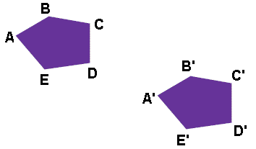

State whether each transformation appears to be an isometry. Explain

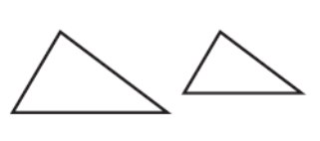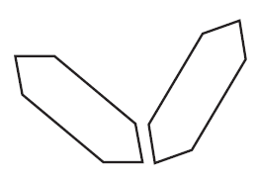

Find the translation image under the following translation:
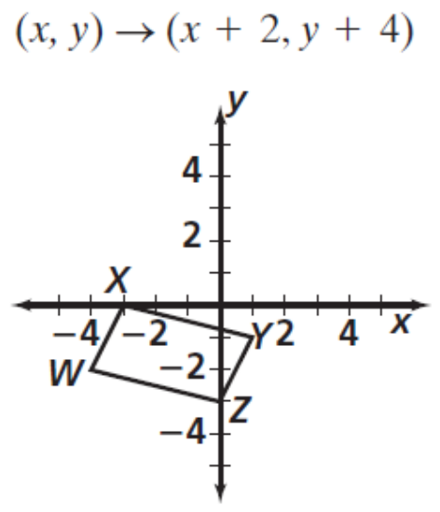
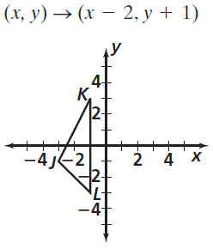
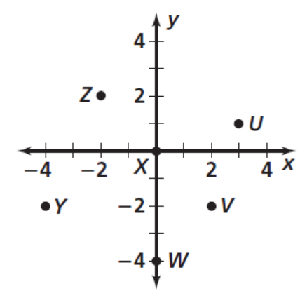  Write a rule that describes the translation  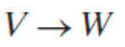  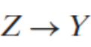 | 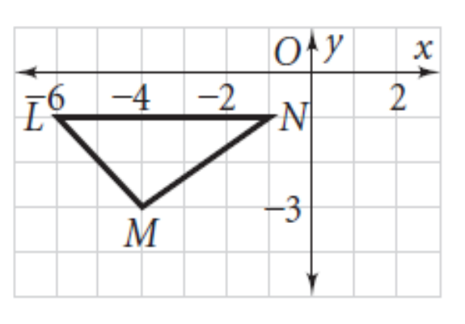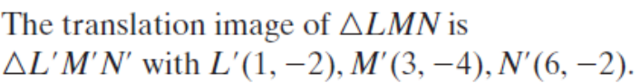

Composition of Transformations:

Joe rides his bike 3 blocks north and 5 blocks east of a pharmacy to deliver a prescription. Then he rides 4 blocks south and 8 blocks west to make a second delivery. How many blocks is he now from the pharmacy?

Sara walks from her hotel to a restaurant 2 blocks east and 4 blocks south. Then walks to a museum 5 blocks west and 3 blocks north. How many blocks is she away from her hotel?

9-2: Reflections

Objectives: To find reflection images of figures

Patty Paper Activity

Reflections:

Summary from the activity:

Notation:

Reflecting on the Coordinate Plane
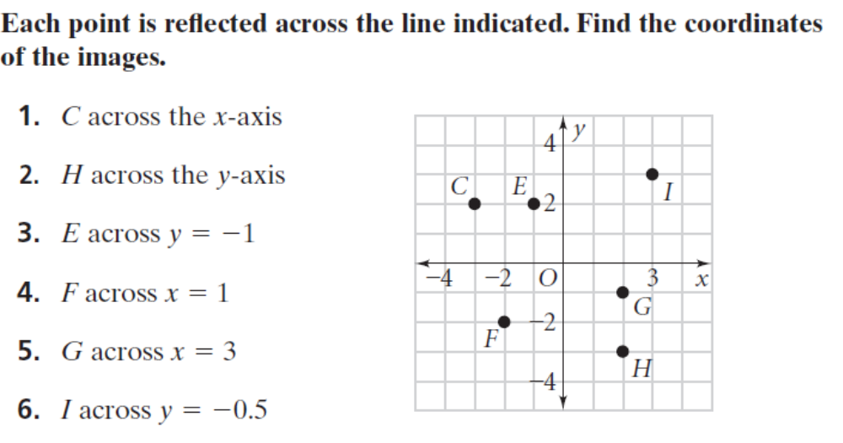
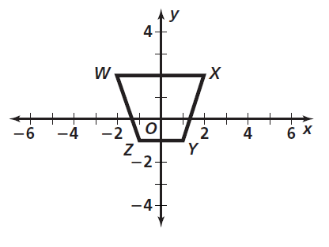  For the figure, draw the reflection image across the indicated line:  x-axis | For the figure, draw the reflection image across the indicated line:  y = 4

Reflecting using a protractor and ruler:
- Place your protractor so that the 90 degree mark and the center of the protractor are on the line
- Slide the protractor along the line so that the base line of the protractor goes through the point
- Measure the distance from the point to the line
- Measure the same distance on the other side of the line to locate the image point. Make sure to keep your protractor on the line to ensure a 90 degree angle.

9-3: Rotations

Objectives: Draw and identify rotation images of figures

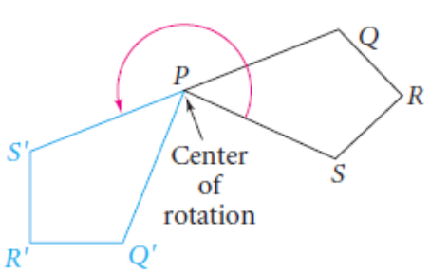
Center of Rotation:

Angle of Rotation:

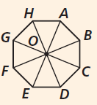  Name the center:  How would you find the angle of rotation from one vertex to the next? | Name the image for the given rotation (use figure to the left):  - 135 degree rotation of A about O  - 270 degree rotation of segment DE about O  - 90 degree rotation of triangle AOB about O going clockwise

To Rotate:

9-4: Symmetry

Objectives: Identify the type of symmetry in a figure

What is Symmetry?

Types of Symmetry:

Reflectional Symmetry  Or  Line Symmetry | Rotational Symmetry
Point Symmetry

Draw all lines of symmetry for the following:

Rectangle Isosceles Trapezoid
Judging from appearance, do the following have rotational symmetry? If so, give the angle of rotation.

H V

Tell whether the umbrella has rotational symmetry about a line and/or reflection symmetry.
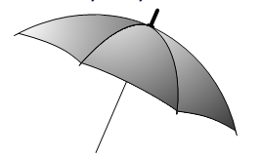

A nut holds a bolt in place. Some nuts have square faces, like the top view shown below. Tell whether the nut has rotational symmetry and/or reflection symmetry. Draw all lines of symmetry

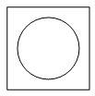

Draw a shape with the following symmetry
Reflection Only | Rotational Only | Both | Neither

9-5: Dilations

Objectives: Locate dilation images of figures

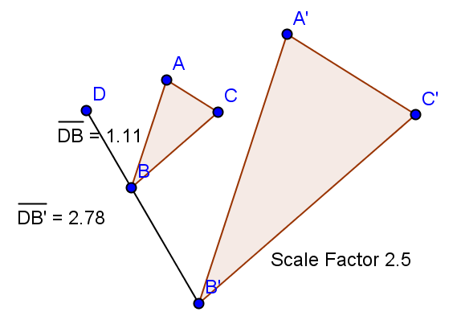A dilation is a transformation whose

Steps to Dilate a Figure

A dilation is an enlargement if | A dilation is a reduction if
Describing a Dilation
To find a scale factor, it can help if you first take a good look at whether you’re looking at an enlargement or a reduction. Take a measure on the new shape and divide by the corresponding measure on the old shape to find the scale factor. Try this for each side to see if the scale factor is the same.

1. Quadrilateral J’K’L’M’ is the image of quadrilateral JKLM. Describe the dilation.  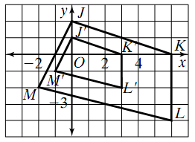 |  | 2. The eight of a tractor-trailer truck is 4.2 m. The scale factor for a model truck is 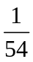. Find the height of the model to the nearest centimeter.
3. Find the image of PZG for a dilation with center (0,0) and a scale factor ½. Draw the reduction on the grid and give the coordinates of the image’s vertices. |  | 4. ΔABC has vertices A(-2, -3), B(0, 4), and C(6, -12). What are the coordinates of the image of ΔABC for a dilation with center (0, 0) and scale factor .75?
  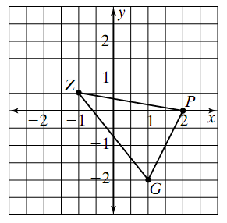 | Vertices  P’  G’  Z’
5. Circle A with 3-cm diameter and center C is a dilation of concentric circle B with 8-cm diameter. Describe the dilation. |  | 5. The scale factor on a museum’s floor plan is 1:200. The length and width of one wing on the drawing are 8 in. and 6 in. Find the actual dimensions of the wing in feet and inches.

Find S_{0.5}(ΔCDE) with center A.  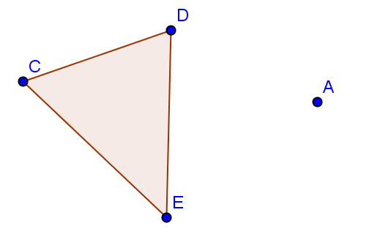 |  | Find S₂(ABCD) with center C.  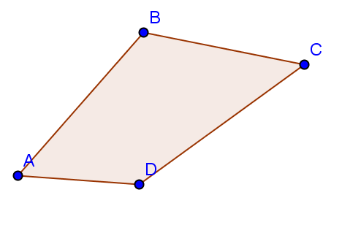

Find the center and scale factor for the dilation that maps ΔABC onto ΔA’B’C’. 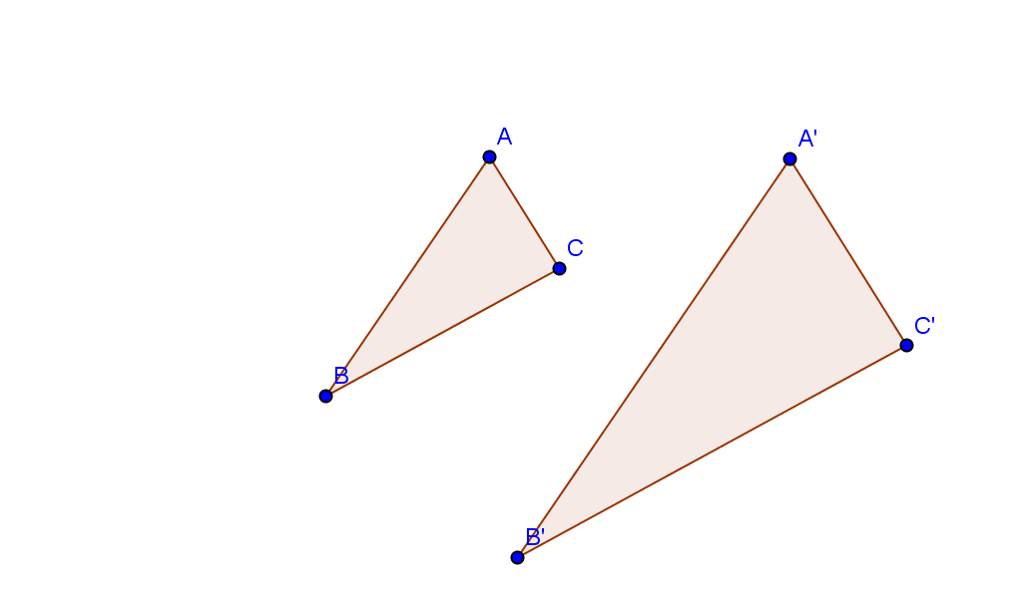

9-6: Composition of Reflections

Objectives: Use a composition of reflections. Identify Glide Reflections

Activity 1:
- Draw 2 parallel lines on another piece of paper. Do not put them close together.
- Draw a triangle on the left side of the first line.
- Reflect your triangle over both lines.

- Measure the distance between the parallel lines
- Measure the distance between corresponding vertices in the pre-image to the image.
- What do you notice?

Activity 2:
- Draw 2 intersecting lines on another piece of paper.
- Draw a triangle to the left of the first line (not in between the lines)
- Reflect the triangle over both lines

- What type of isometry did you make?
- Measure the angle that is formed by the intersecting lines
- Measure the angle that is formed by connecting a vertex in the pre-image to the point of intersection and then to the corresponding point in the image
- What do you notice?

Summary:

A _____________________ is a composition of two reflections.

A composition of reflections across two parallel lines is a _____________________

A composition of reflections across two intersecting lines is a _____________________

Glide Reflection:

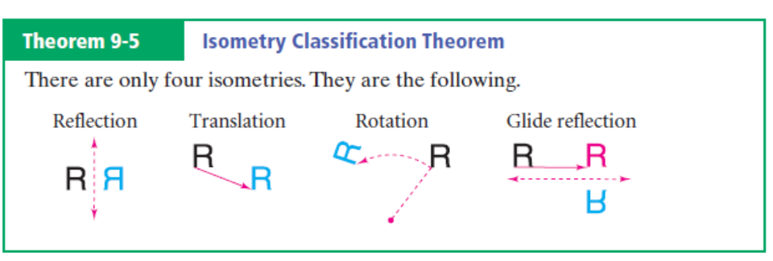

Judging by the appearance, is one figure a translation image of the other, rotation image, or neither? Explain

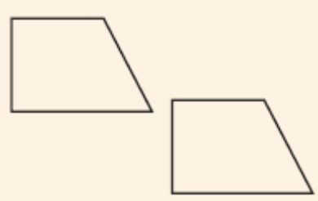
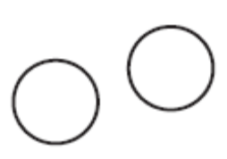
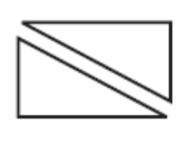

1. Match each image of the figure on the left with its isometry
 |  |  |  |  | 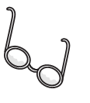
Original Image | _______________ | _______________ | _______________ |  | _______________
2. a) Find the image of ΔTEX under a glide reflection where the translation is (x, y) → (x + 1, y) and the reflection line is y = -2. Draw the translation first, then the reflection.  b) Would the result of part (a) be the same if you reflected ΔTEX first, and then translated it? Explain. |  |  |  | 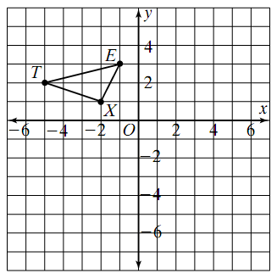

Practice Compositions over intersecting and parallel lines

9-7 Tessellations

Objectives: Identify transformations in tessellations, and figures that will tessellate. Identify symmetries in tessellations

Tessellation:

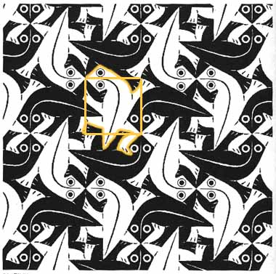
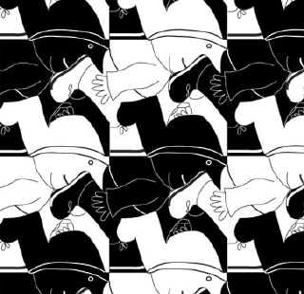

What figures Tessellate?

For a figure to tessellate, the sum of the measures of the angles around any vertex must equal 360 degrees.

- Use the formula to find the measure of an angle for a regular polygon
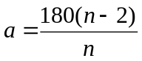

- If that number is a factor of 360, the figure will tessellate

**Therefore, EVERY _________________ will tessellate and EVERY ___________________will tessellate.

Examples: Will the figure tessellate? Explain.

Rhombus Regular 15-gon Acute Triangle Regular Octagon

There are symmetries in Tessellations
- Translational
- Glide Reflectional
- Rotational
- Point
- Line

Identify the Symmetries
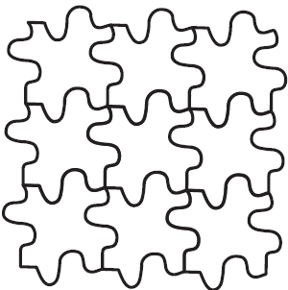
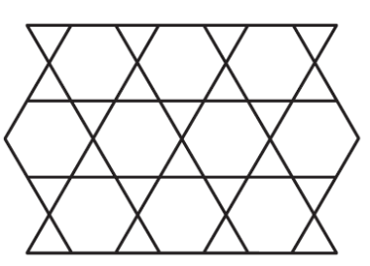
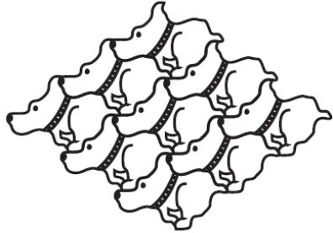

Your Very Own Tessellation!!!!!
- Activity in blue on page 517 in book
- Tessellate an 8x10 piece of paper
- Color and Decorate your tessellation
- Be creative J
- Attach the figure you tessellated to the picture

- Due Monday, March 25

