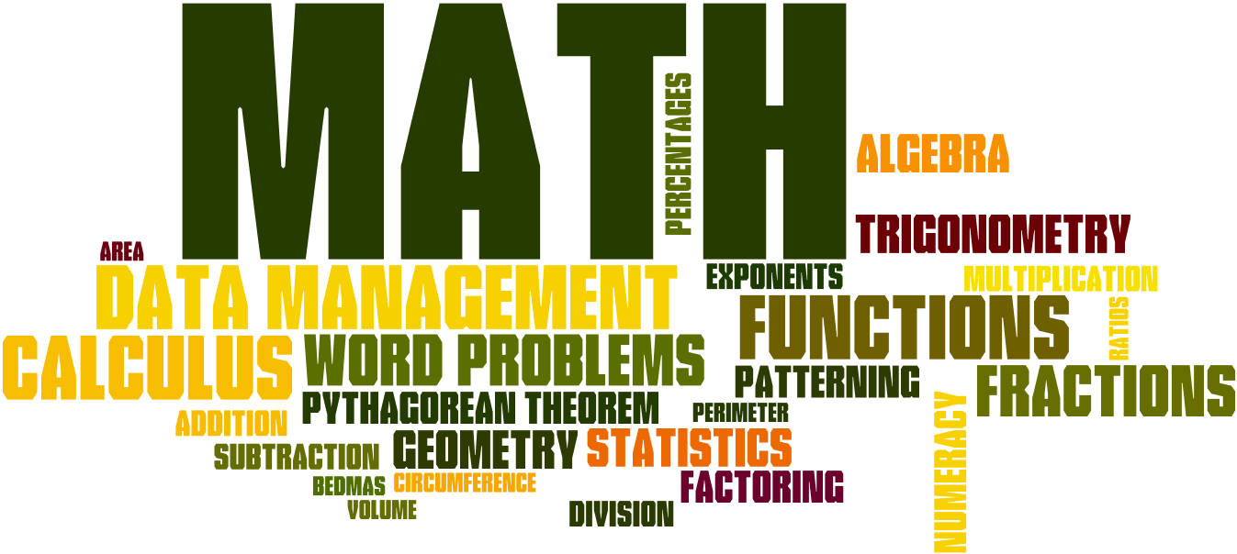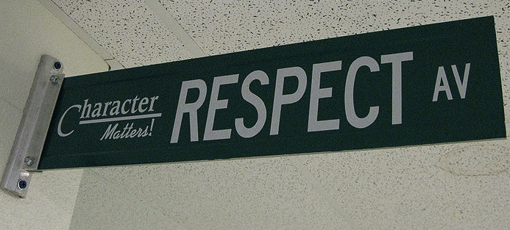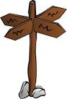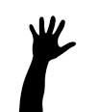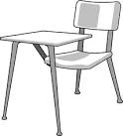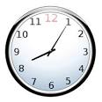

Welcome to Geometry. In this class we will have in-depth analysis of plane, solid, and coordinate geometry as they relate to both abstract mathematical concepts as well as real-world problem situations. Topics include logic and proof, parallel lines and polygons, perimeter and area analysis, volume and surface area analysis, similarity and congruence, trigonometry, and analytic geometry. Emphasis will be placed on developing critical thinking skills as they relate to logical reasoning and argument. Students will be required to use different technological tools and manipulatives to discover and explain much of the course content.

Homework is not busywork. It is necessary for you to complete in order to participate in class the next day or to develop important skills. My website contains a calendar of homework assignments to help you keep track of your assignments. If you choose not to complete the assigned work, you are missing out on the opportunity to learn and grow. In the past, students who didn’t complete homework struggled to complete Geometry, while students who regularly completed homework succeeded.

You will be given homework daily, however, you will usually have time in class to work on the assignment. The next day, we will go over any questions on the homework. The day of the quiz, you will be given an Assignment Accuracy Check (AAC) and this will count towards your homework grade. It will consist of 5 questions from your homework set and they are graded on accuracy.

## Homework

# Course Description

#### Be kind & be respectful.

### Class Expectations

#### Follow directions the first time they are given.

#### Raise your hand and wait to be called on before speaking.

All school rules also apply.

#### Complete all activities and assignments

#### Be on time & be prepared.

Geometry

**Email**: [khop@fhps.net](mailto:khop@fhps.net)

**Website**: hopmathematics.weebly.com

**Online Book**: pearsonsuccessnet.com

Username: FHEHawks1718

Password: algebra1

**Online Resources**: phschool.com

IXL.com

## Important Information:

**YOU WILL NEED:**

* Folder/binder
* Pencils only!!
* Calculator
* Compass & Protractor
* Electronic device to complete online assignments (no phones). If you do not have one, there are chromebooks in the classroom.
* A positive attitude, a sense of humor, & an open mind

**Entering Class:** Gather any necessary materials, turn in any assignments, and quickly find your seat.

**Food & Drink:** Food and drink are permitted, however, please clean up after yourself.

**Phones**: **should not** be seen or heard in the classroom. They should be kept in your locker or backpack at all times.

**Absences:** If you are absent, it is your responsibility to make up missed assignments. See the “Absent” folder for handouts.

**Test Retakes:** If you did not pass a test, you do have the opportunity to retake the test. You will need to complete a review packet before retaking the test. After the packet is complete and corrected, you may retake the test before or after school.

**Missing Assignments:** You may not make up any missing questions on the AAC

## Classroom Policies, Procedures, & Grading