Geometry 1st Semester Exam Review
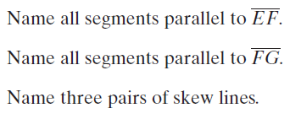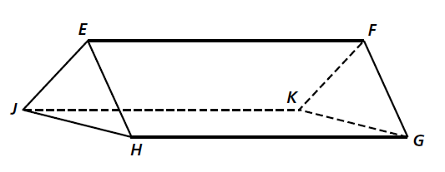 | 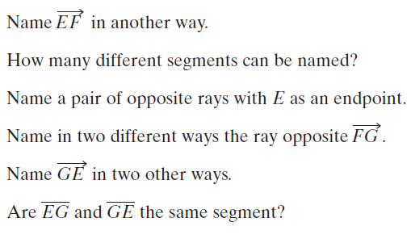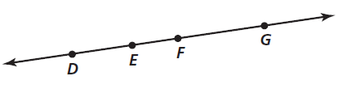
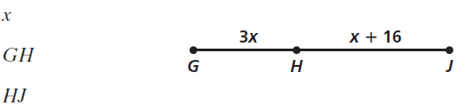 | 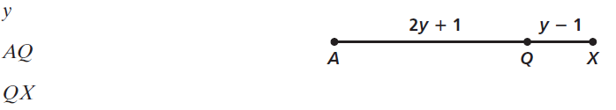
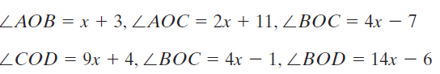
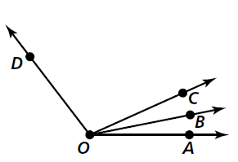
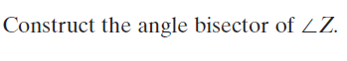
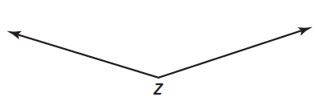
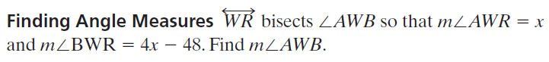  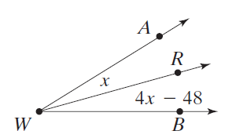 |  | Find the distance between the points to the nearest tenth.  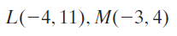  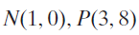
Show that each conditional is false by finding a counterexample:  If it is 12:00 noon, then the sun is shining.  If a number is divisible by 3, then it is odd | Write the converse of each statement. If the converse is true, write true; if it is not true, provide a counterexample.  If x - 4 = 22, then x = 26  If point A is in the first quadrant of a coordinate plane, then  x > 0
Each condition statement is true. Consider each converse. If the converse is true, write a biconditional.  If two angles have the same measure, then they are congruent.  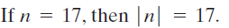 | Write the two conditional statements that make up each biconditional.  A whole number is a multiple of 5 if and only if its last digit is either a 0 or a 5.  Two lines are perpendicular if and only if they intersect to form four right angles.
Use the Law of Detachment to draw a conclusion.  If the measures of two angles have a sum of 90 degrees, then the angles are complementary.  m<A + m<B = 90  If the football team wins on Friday night, then practice is cancelled for Monday.  The football team won by 7 points on Friday night. | Use the Law of Detachment and the Law of Syllogism to draw a conclusion from the following statement.  1) If it is raining, the temperature is greater than 32 degrees  2) If the temperature is greater than 32 degrees, then it is not freezing outside.  3) It is raining  1) If you live in Providence, then you live in Rhode Island  2) If you live in Rhode Island, then you live in the smallest state in the United States.  3) Shannon lives in Providence
Give a reason for each step  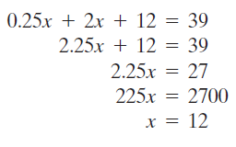 | Name the property that justifies each statement  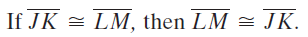
Find the values of the variables
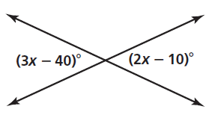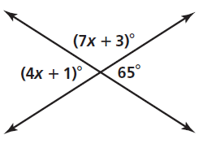

Which lines or segments are parallel?  Justify your answer with a theorem or postulate.  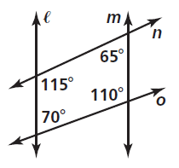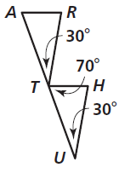 |  | Classify each triangle by its sides and angles
Find the measure of each numbered angle  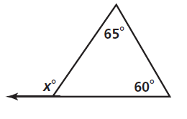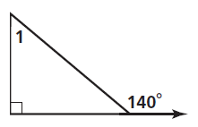  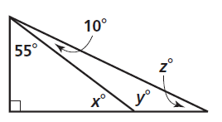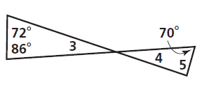 |  | Tell whether the ASA, AAS, SSS, SAS postulate can be applied to determine if the triangles are congruent.  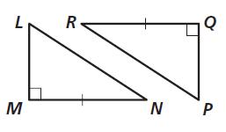  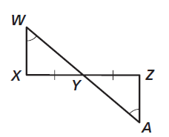
Write a two-column proof
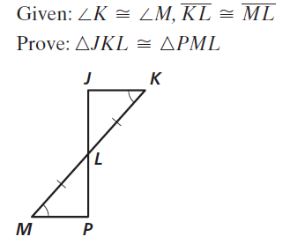
Write a two-column proof
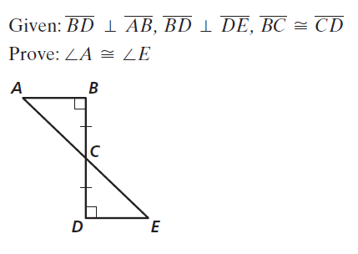

Write a two-column proof
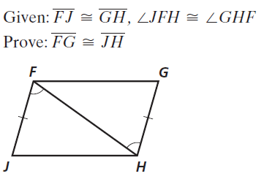

Find the values of the variables:
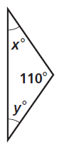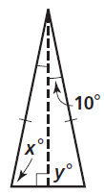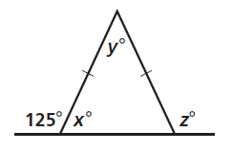

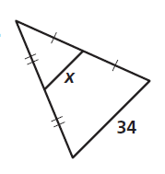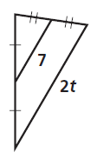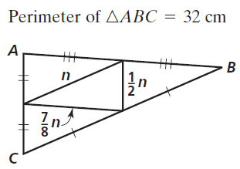

Use the figure to answer the following questions:
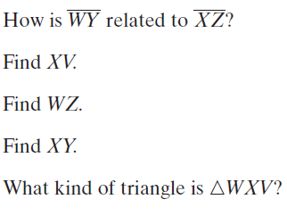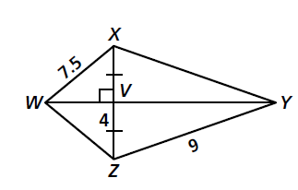
Use the figure to answer the following questions:
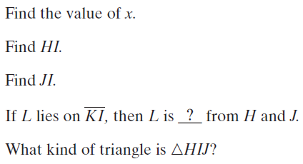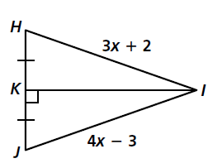

G is the centroid of ΔABC, AD = 8, AG = 10, and CD = 18. Find the length of the segment.
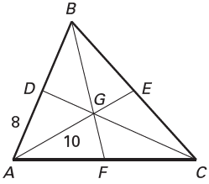
1. $\overline{BD}$ 2. $\overline{AB}$ 3. $\overline{EG}$

4. $\overline{AE}$ 5. $\overline{CG}$ 6. $\overline{DG}$

Write the negation of each statement:  - The angle measure is 65  - The restaurant is not open on Sunday | Write the Inverse and Contrapositive of each statement. Give the truth value of each:  - If two triangles are congruent, then their corresponding angles are congruent  - If you live in Toronto, then you live in Canada
List the angles of each triangle in order from largest to smallest:  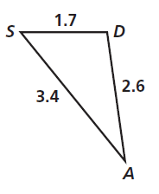  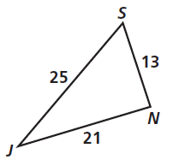 | List the sides of each triangle in order from largest to smallest:  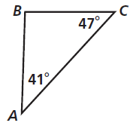  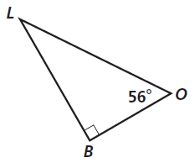
Find the value of each variable. Leave your answer in simple radical form  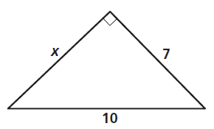  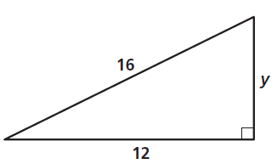 | Find the value of each variable. Leave your answers in simple radical form  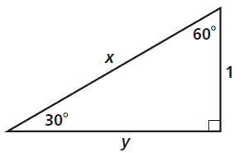  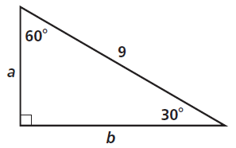  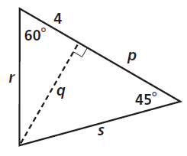  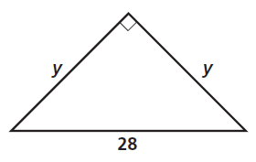
Find the value of x. Round your answer to the nearest degree  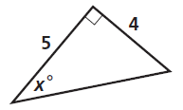  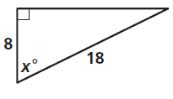 | Write the ratios for sin P and cos P  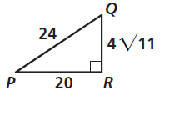  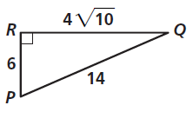
Find the value of x. Round the lengths to the nearest tenth.  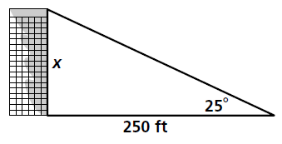  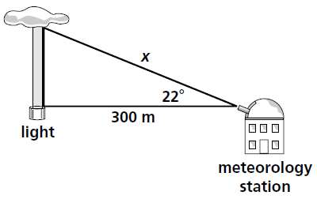  A person is standing 30 ft from a flagpole can see the top of the pole at a 35 degree angle of elevation. The person’s eye level is 5 ft from the ground. Find the height of the flagpole to the nearest foot. | Find the indicated side/angle:  Find AC  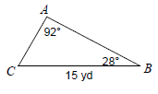  Find angle A  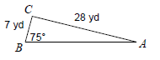  Find AB  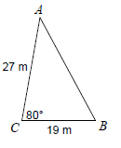  Find angle A  