SUPERHERO PROJECT
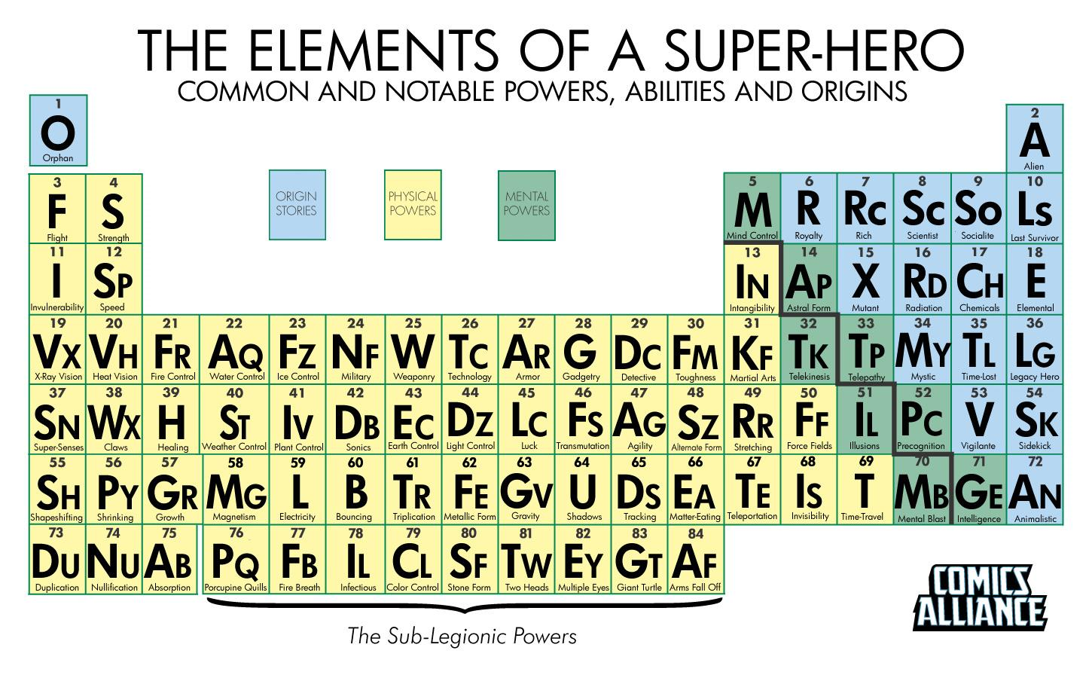
OBJECTIVE: This project is to demonstrate your understanding of exponential growth and decay. To do so you and your partner are going to create a comic book where exponential growth/decay are evident. For example: bacteria (created by your villain) that grows at an exponential rate and is infecting a growing number of people (growth) while the population of the world is quickly decreasing (decay) this requires saving the human race. You will be reading these comics to elementary students at FHPS.
HOW: With your partner you will develop a concept for an original superhero with powers taken from the given periodic table (you must choose either mental or physical). You will also create an arch-nemesis for the superhero (villain) using the same periodic table and choosing either mental or physical powers. The numbers of the powers you choose must add to a number between 50 and 90. For example: The superhero has the power of duplication (73) and the villain has the power of speed (12), so their powers together add to 85 (73+12=85).
You will need to create a backstory for both characters, what their superpower are, any associate characters they interact with, and a plot for a story. The backstory for where your hero villain’s powers originate can be found on the given periodic table as well (blue squares). You must choose an origin story for both that add to an odd number between 41 and 73. For example, the superhero has a backstory/origin involving being an orphan (1) and the villain has a backstory/origin involving a vigilante (53), so their backstories/origins together add to 54 (1+53).

FHPS is excited to share these comic books with their students and we are excited to show them what we’re capable of producing!

GRADING: You will be assessed on creative & critical thinking within your project. You will also be assessed on your understanding of exponential growth and decay and its clear presence in your comic.
****In order to go on the field trip to read your comic to elementary students you MUST turn your project in on the day of the due date. If the project is not turned in by this date you will not be allowed to come on the trip. You are STRONGLY encouraged to dress as your superhero/a superhero on the day of the trip.
WHAT THE COMIC BOOK SHOULD CONTAIN:
- Cover with title and names of authors
- Backstory (origin) for both the superhero and the villain
- Powers of superhero and villain
- Plot that clearly relates to exponential growth and decay

HELPFUL LINKS:
Character Design Template:
http://www.flyingchipmunkcomicspress.com/webcomic_templates/Character_Design_Sheet_Hz.pdf
Storyboard Template:
http://www.rodypolis.com/15/post/2012/07/storyboards-free-template.html
Superhero Creation Ideas (See Links on Top Left Side):
http://www.superheronation.com/2008/12/07/how-to-storyboard-a-comic-book/
Template for Comic Book Pages:
http://www.printablepaper.net/category/comics
Blank Template for Comic Book Cover:
http://comicsforbeginners.com/files/2013/08/comic-book-template-US-letter.pdf

Superhero Project Rubric
Backstory/Origin Story  ______/20 | The origin stories for the villain and the hero add to an odd number between 41 and 73. The stories outline how they got their powers along with the history of both the villain and the hero.  (20 points) | Both the villain and the hero have backstories that come from the given origins but the outline of how they got their powers along with their histories is slightly disconnected.  (11-19 points) | The backstories for the villain and hero are very lacking or nonexistent. There is little or no connection to their powers and the given table.  (0-10 points)
Exponential Growth/Decay  _______/20 | The comic plot clearly relates to both exponential growth and decay and demonstrates clear understanding of what both are.  (20 points) | The comic plot shows some connection to both exponential growth and decay and demonstrates some understanding of what both are.  (11-19 points) | The comic plot shoes little connection to exponential growth and/or decay and demonstrates little to no understanding of what both are.  (0-10 points)
Powers/Originality  ______/10 | The powers of both the hero and the villain come from the given table and add to a number between 50 and 75. The comic is an original work with characters and a plot that are creative and understandable.  (10 points) | The powers of both the hero and the villain come from the given table but do not follow all guidelines (mental OR physical/add to 50-75). The comic is a somewhat original work with characters and a plot that are somewhat creative and understandable.  (5-9 points) | The powers of both the hero and the villain have little to no connection to the table. The guidelines (mental OR physical/add to 50-75) are not followed closely. The comic is not very original with characters and a plot that lack creativity and are somewhat confusing.  (0-4 points)
Visual  ______/10 | The project is well organized and neatly put together. The project follows all requirements and shows a clear, consistent plot and is colored with all original drawings.  (10 points) | The project is somewhat organized and neatly put together. The project follows most requirements and shows a somewhat clear, consistent plot and is colored with all original drawings.  (5-9 points) | The project is poorly organized and somewhat messy. The project follows few requirements and shows an unclear, inconsistent plot and is not colored with unoriginal drawings.  (0-4 points)

